

# CS 305 Project Two

**Practices for Secure Software Report**

**Table of Contents**

Document Revision History 3

Client 3

Instructions 3

Developer 4

1. Algorithm Cipher 4

2. Certificate Generation 4

3. Deploy Cipher 4

4. Secure Communications 4

5. Secondary Testing 4

6. Functional Testing 5

7. Summary 5

## Document Revision History

| **Version** | **Date** | **Author** | **Comments** |
| --- | --- | --- | --- |
| **1.0** | **4/16/2022** | **Rico Applewhite** |  |

## Client



## Instructions

Deliver this completed Practices for Secure Software Report documenting your process for writing secure communications and refactoring code that complies with software security testing protocols.

Respond to the steps outlined below and replace the bracketed text with your findings in your own words. If you choose to include images or supporting materials, be sure to insert them throughout.

## Developer

Rico Applewhite

## 1. Algorithm Cipher

Determine an appropriate encryption algorithm cipher to deploy given the security vulnerabilities, justifying your reasoning. Be sure to address the following:

* Provide a brief, high-level overview of the encryption algorithm cipher.
* Discuss the hash functions and bit levels of the cipher.
* Explain the use of random numbers, symmetric vs non-symmetric keys, and so on.
* Describe the history and current state of encryption algorithms.

Encryption algorithm cipher helps secure data between communications. It does this by encrypting it so no one can read or see it except for its intended audience. The data is converted into ciphertext in which a specific key is needed to convert it back. Hash functions map data to an array and give it a hash value. This function is nearly impossible to reverse so unless you have the hash value or perform a brute force attack, the data will stay secure. Each bit in a cipher is just a tiny piece of the information. The more bit in encryption the longer the key length and the longer the key length means it harder to crack. Random Numbers are used in keys to help prevent brute force attacks, which are attacks where every possible key is tried until the right one is found. A symmetric algorithm means only one key is generated to encrypt and decrypt the data, as opposed to a non-symmetric algorithm that has a key for encrypting and a separate key for decryption.

## 2. Certificate Generation

Generate appropriate self-signed certificates using the Java Keytool, which is used through the command line.

* To demonstrate that the keys were effectively generated, export your certificates (CER file) and submit a screenshot of the CER file below.

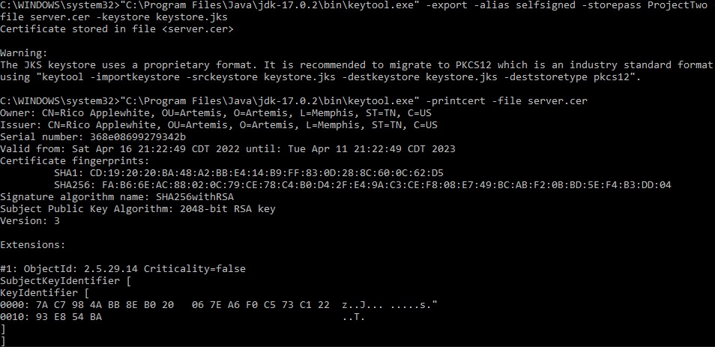

## 3. Deploy Cipher

Refactor the code and use security libraries to deploy and implement the encryption algorithm cipher to the software application. Verify this additional functionality with a checksum.

* Insert a screenshot below of the checksum verification. The screenshot must show your name and a unique data string that has been created.



## 4. Secure Communications

Refactor the code to convert HTTP to the HTTPS protocol. Compile and run the refactored code to verify secure communication by typing **https://localhost:8443/hash** in a new browser window to demonstrate that the secure communication works successfully.

* Insert a screenshot below of the web browser that shows a secure webpage.



## 5. Secondary Testing

Complete a secondary static testing of the refactored code using the dependency check tool to ensure code complies with software security enhancements. You only need to focus on the code you have added as part of the refactoring. Complete the dependency check and review the output to ensure you did not introduce additional security vulnerabilities.

* Include the following below:
  + A screenshot of the refactored code executed without errors
  + A screenshot of the dependency check report

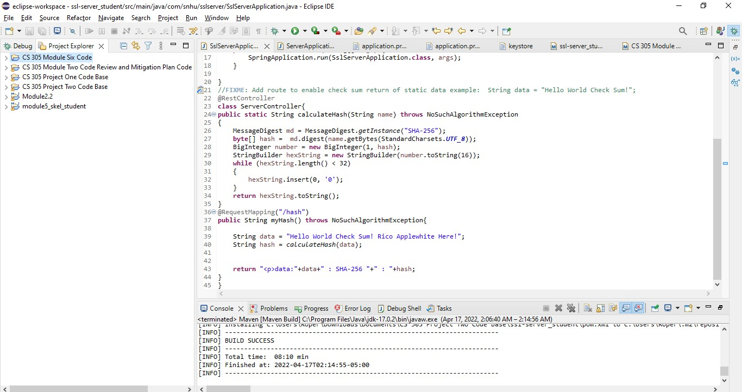

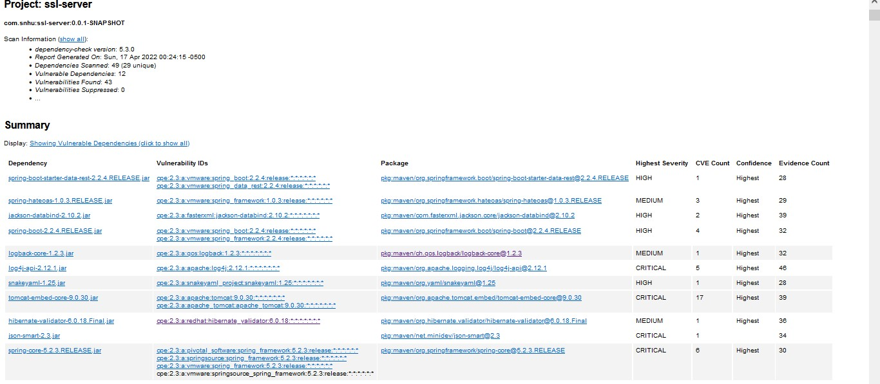

## 6. Functional Testing

Identify syntactical, logical, and security vulnerabilities for the software application by manually reviewing code.

* Complete this functional testing and include a screenshot below of the refactored code executed without errors.



## 7. Summary

Discuss how the code has been refactored and how it complies with security testing protocols. Be sure to address the following:

* Refer to the Vulnerability Assessment Process Flow Diagram and highlight the areas of security that you addressed by refactoring the code.
* Discuss your process for adding layers of security to the software application and the value that security adds to the company’s overall wellbeing.
* Point out best practices for maintaining the current security of the software application to your customer.

By refactoring the code we address many areas in the Vulnerability Assessment Process Flow Diagram, the main being cryptography. Others include APIs, Code Error, and Quality. We addressed the whole row In the Code Review portion of the Diagram as we review security controllers, plugins, and services.The code has been refactored to encrypt sensitive data. For any company security is important but for financial companies like Artemis, it is critical. Thousand of customers are trusting them with their financial well-being. I single hack could break that trust and they won’t hesitate to take their business somewhere more secure.Technology is advancing at a rapid pace and so are those who seek to exploit it. The best practice for maintaining the security of the software is to update it regularly. What’s secure today might not be in a few months so constant updates